Database Design CS 6360

Project Phase I

**Team Member**

Yuchuan Liu 2021184144

Xian Shi 2021187621

Jiaming Fan 2021225346

# EER Diagram

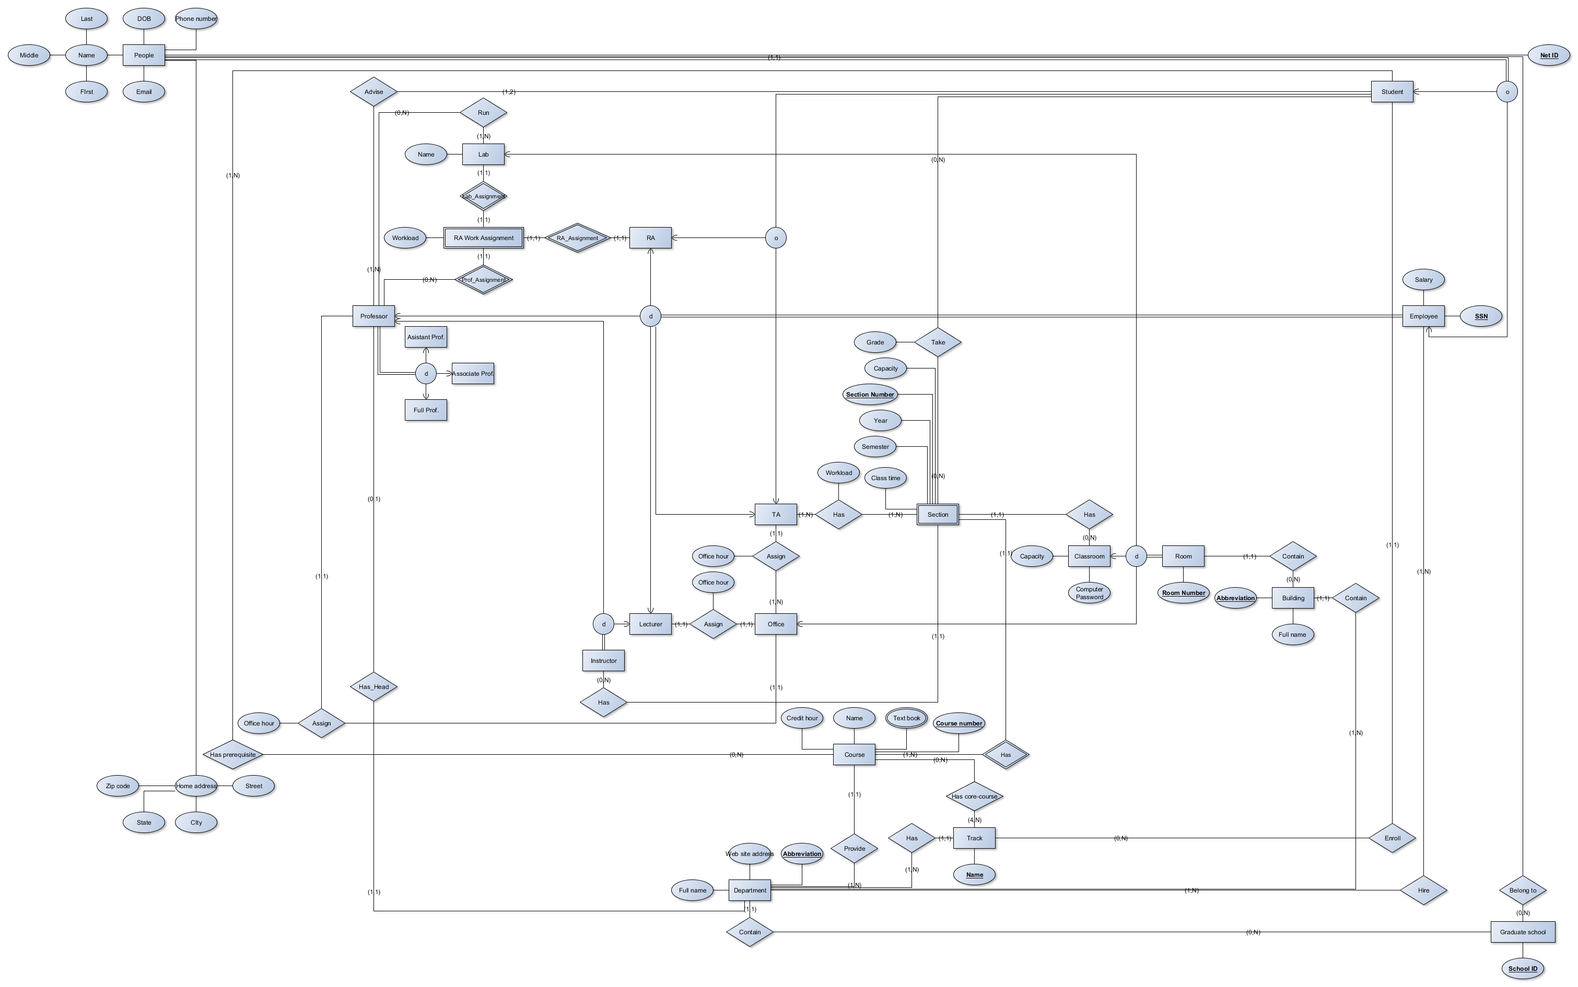

# EER Notation Clarify

We use  to instead  notation in EER diagram.

We put participation role into relationship type name since our EER editor tool cannot make graph clearer if we keep them on line.

Other notations are remain same with EER diagram notations.

# EER Assumptions

1. One Graduate School must have one department.
2. Abbreviation of department is key attribute for department.
3. One Building can only belongs to one Department.
4. Abbreviation of building is key attribute for building.
5. One room must belongs to only one building.
6. Room Number attribute of room is key.
7. People can only and must belongs to one graduate school.
8. Net Id of people is key.
9. SSN of employee is key.
10. Each Department at least hires one employee.
11. Student at least is advised by one professor.
12. Professor could be head of only one department.
13. Not every student is a RA or TA.
14. Each Department at least provides one course.
15. Each course can be only provided from one department.
16. Section Number is partial key.
17. TA at least works for one section.
18. Department has at least one track.
19. Each Track must belong to only one department.
20. Name of track is key.
21. Graduate School has key attribute school id.